Copy for CDP Resource 3: Click here for sample flyer
28 Sep 23

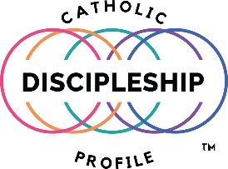

DISCOVER HOW GOD IS WORKING IN YOUR LIFE

Scan the QR code below

(Your parish logo) (QR code from your CDP parish registration link) (Your parish logo)

Or visit

(Your parish website URL)

Scroll down the homepage and click on

Take the Catholic Discipleship Profile
(use your CDP parish registration link)

